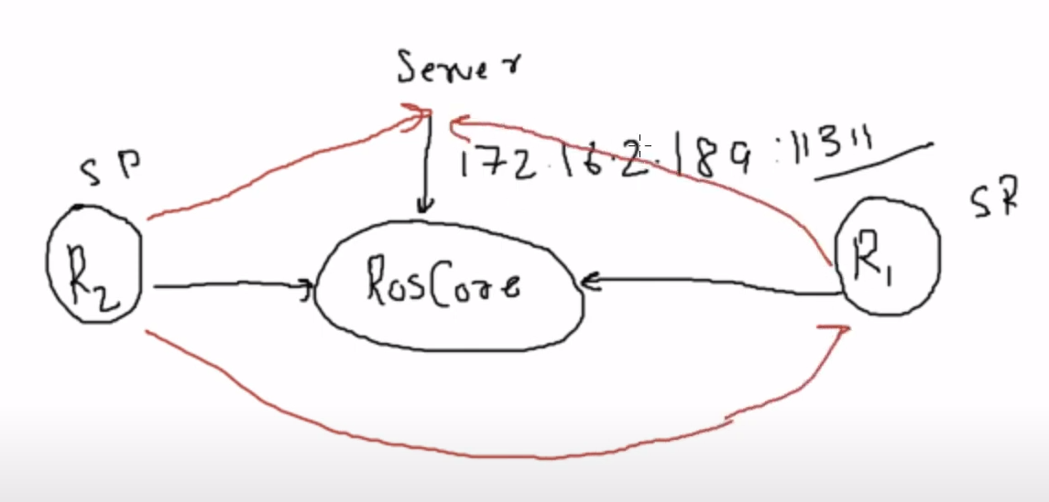

<https://www.youtube.com/watch?v=zB_hVtIvoRQ>

HOW TO CONNECT TWO LAPTOPS AND RUN SAME ROSCORE ON BOTH OF THEM:

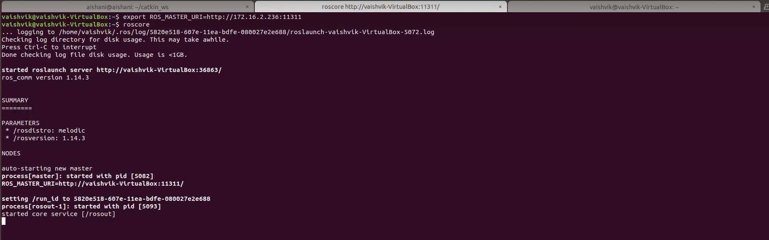



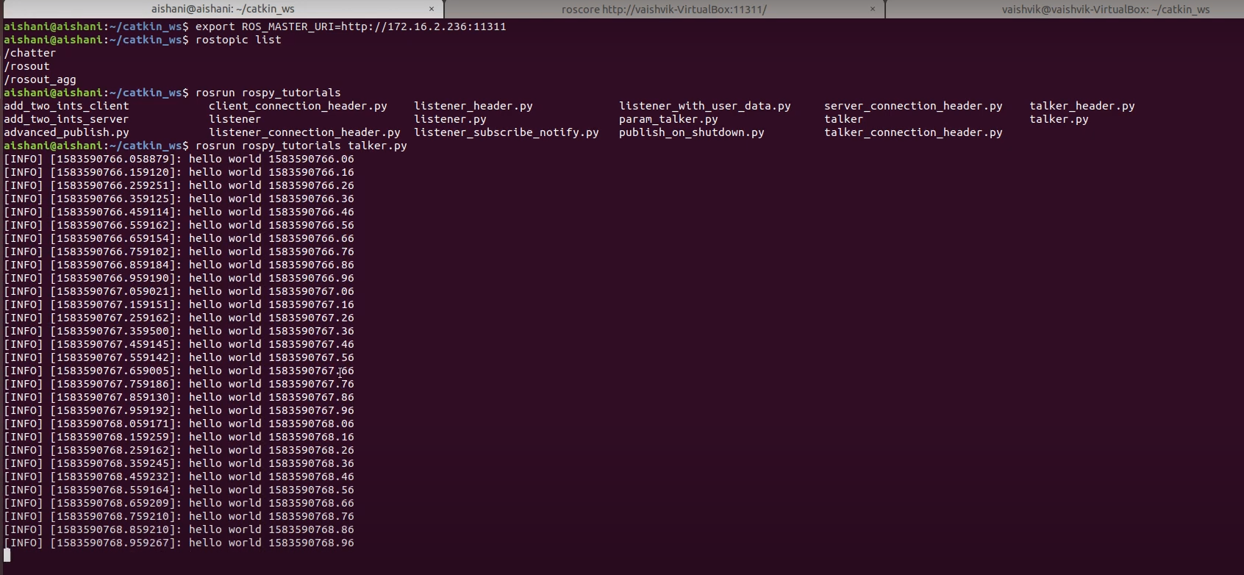



Preferred Ways to connect robots and laptop

1. Wifi
2. Zigbee
3. Bluetooth

file:///home/visit/Downloads/ZigBee Implementation MultiRobotSystem.pdf

**Wi-Fi:**

**Advantages:**

Higher data transfer rates: Wi-Fi typically offers faster data transfer rates, making it suitable for transmitting large amounts of data quickly.

Longer range: Wi-Fi can cover longer distances, which might be necessary in a large warehouse.

Flexibility: Wi-Fi supports complex network topologies and can handle a greater number of devices simultaneously.

Well-established: Wi-Fi is widely used and supported, and there are many resources available.

**Limitations:**

Higher power consumption: Wi-Fi modules tend to consume more power, which could impact battery life in mobile robots.

More susceptible to interference: In crowded environments, Wi-Fi can suffer from interference.

**Conclusion:** Wi-Fi can be a good choice if data transfer speed, range, and network complexity are crucial for your warehouse application. However, you'll need to manage power consumption effectively, especially if your robots are battery-powered.

Wifi / bluetooth module for jetson nano:  
<https://www.amazon.in/Waveshare-AC8265-Wireless-Supports-Bluetooth/dp/B07SGDRG34>

**Bluetooth:**

**Advantages:**

Low power consumption: Bluetooth, especially Bluetooth Low Energy (BLE), is known for its power efficiency, which is beneficial for battery-powered robots.

Simplicity: Bluetooth has a straightforward pairing process and is suitable for quick robot-to-robot connections.

Suitable for short-range communication: If the robots will be relatively close to each other in the warehouse, Bluetooth can be effective.

**Limitations:**

Limited data transfer rate: Bluetooth's data transfer rates are moderate, which might be a limitation if you need to transfer large amounts of data quickly.

Shorter range: Bluetooth has a shorter range compared to Wi-Fi.

**Conclusion:** Bluetooth is a good choice if power efficiency is a priority, and you don't need extremely high data transfer rates or a long communication range. It's particularly suitable for short-range interactions.

**Zigbee:**

**Advantages:**

Low power consumption: Zigbee is designed for low-power applications, making it suitable for battery-powered robots.

Mesh networking: Zigbee supports mesh network topologies, which are beneficial for complex robot interactions in large warehouses.

Resilient to interference: Zigbee operates in a dedicated frequency band, making it resilient to interference.

**Limitations:**

Limited data transfer rate: Zigbee offers lower data rates, so it's better for lightweight data.

**Conclusion:** Zigbee is a good choice if you prioritize low power consumption and require complex networking capabilities within your swarm of robots. It's well-suited for large warehouse environments where interference may be a concern.

Zigbee module:

<https://robocraze.com/products/xbee-s2c>

**ZIGBEE:**